

**E PROJECT**

SAFE CARZ LIMITED

DESIGN DOCUMENT

**SAFE CARZ LIMITED**

|  |  |  |
| --- | --- | --- |
| **Supervisor.** | **Miss Qurat Ul Ain** | |
| **Batch.** | **2406E1** | |
| **Group.** | **A** | |
| **Serial No.** | **Enrollment Number** | **Student Name** |
| 1. | 1573897 | ABDUL RAHMAN. |
| 2. | 1577874 | HAMMAD RASHID. |
| 3. | 1576369 | NOMAN AHMED SIDDIQUI. |
| 4. | 1578425 | MUHAMMAD SUFIYAN. |
| 5. | 1583637 | MUHAMMAD SAAD. |

**ACKNOWLEDGEMENT**

Before anything, I would like to thanks my beloved Miss Qurat Ul Ain who helped us a lot in reviewing this project within the limited time frame.

Secondly, we would also like to thank the eProject team at Aptech Head Office, who gave us the golden opportunity to do this wonderful project about SAFE CARZ

Thirdly, we also thank the eProject team, some of the benefits are as under: Re-enforcement of skills happens in the experiential learning process. ∙ A mentor, ensuring that we do not get drifted, constantly guides us. ∙ It gives us a lot of confidence to face an interview as we have worked on a project. We can explain virtually everything on the subject we have learnt

**PROBLEM DEFINITION**

Safe Carz Limited is into providing insurance cover for Cars and other vehicles. They provide various insurance policies through different Insurance companies. They now want to provide details of these insurance products on internet. They want to host a website with all the information about their organization and various insurance plans available with them. Requirement Specification: The Web site is to be created based on the following requirements.

**CUSTOMER REQUIREMENT**

**SPECIFICATION (CRS)**

The Web site is to be created based on the following requirements.

1) Home Page should contain logo of the site with proper sections and details of

various Insurance plans available.

2) The site should display a menu which will contain the options for brief

introduction about the various categories and plans available, location of the

shop and any other information if required.

3) The information should be categorized according to the company names of

the Insurance plans like if a User wants to see only “Zurich Insurance” plans

or any other company’s insurance plans then he/she can click on a

Link/button/menu etc and can see only that Companies plans.

4) Another category option for plans of different type of vehicles, like ‘Four

Wheelers’, ‘Two Wheelers’ etc. should be created and accordingly.

5) When a user selects any particular brand, a list of various plans for that brand

will be displayed

6) A brief summary about individual plans should be displayed on the Web Page

along with the base price.

7) There should be a “Contact Us” page which will have the Address of the Store

which is as follows and the mail address which when clicked will invoke the

local mail client from where they can send an email**.**

out the various categories and plans available, location of the

shop and any other information if required.

3) The information should be categorized according to the company names of

the Insurance plans like if a User wants to see only “Zurich Insurance” plans

or any other company’s insurance plans then he/she can click on a

Link/button/menu etc and can see only that Companies plans.

4) Another category option for plans of different type of vehicles, like ‘Four

Wheelers’, ‘Two Wheelers’ etc. should be created and accordingly.

5) When a user selects any particular brand, a list of various plans for that brand

will be displayed

6) A brief summary about individual plans should be displayed on the Web Page

along with the base price.

7) There should be a “Contact Us” page which will have the Address of the Store

which is as follows and the mail address which when clicked will invoke the

local mail client from where they can send an email.

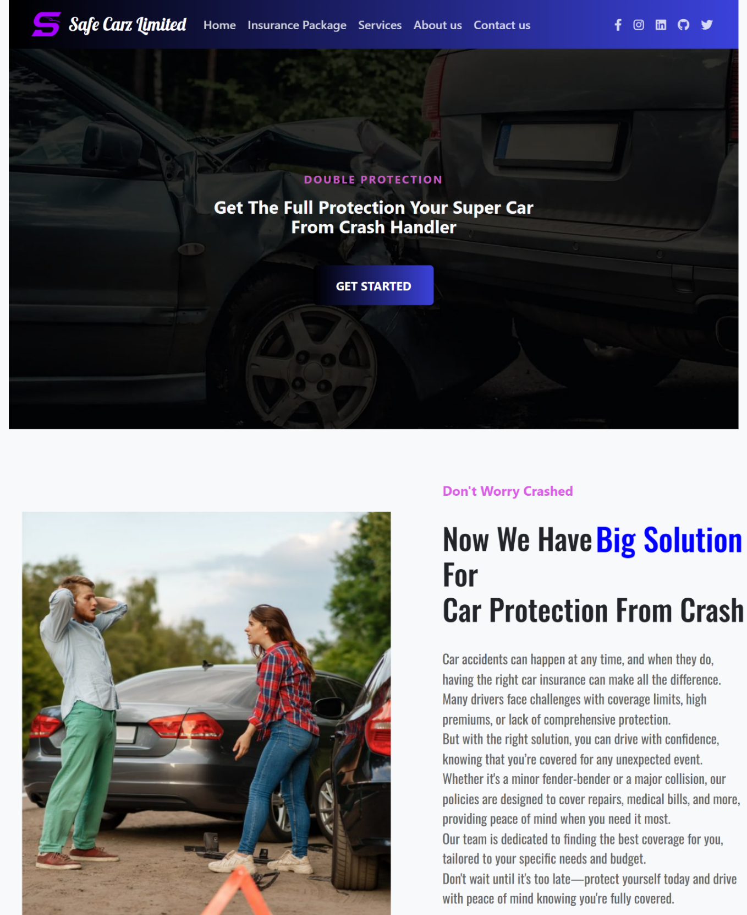**SCREEN SHOTS**

